Brief summary on the International Conference MICRO 2016 in Lanzarote

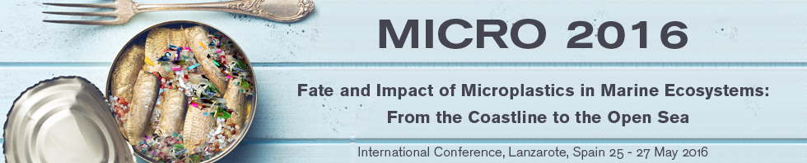

Following the "MICRO 2014" workshop in Plouzané, France, and the "MICRO 2015" seminar in Piran, Slovenia, from 25 to 27 of May 2016 the "MICRO 2016", was hosted in Lanzarote, Canary Islands, during a three-day international conference entitled Fate and Impact of Microplastics in Marine Ecosystems From the Coastline to the Open Sea. This conference was under the patronage of UNESCO.

The scientific committee selected the following topics:
* From macro- to microplastics: Weathering and fragmentation processes
* From source to sink: Occurrence and distribution of microplastics in fresh water bodies, coastal zones and the open ocean
* Impacts of microplastics on marine life
* Microplastics as vectors of biological and chemical contaminants
* Socioeconomic impacts of microplastics
* Citizen science, outreach, education and communication
* Solutions and next steps

Overall, more than 300 participants with 109 Oral presentations and 82 Posters were presented during the three days. Most of them were based on the survey of microplastics in water and sediments. A much lower number of contributions described the presence of microplastics in marine biota, the toxicity of these particles and the overall risks for the marine ecosystem.

Presentations of the EPHEMARE group can be downloaded.

At the end of the conference, the Organizing Board and Scientific Committee presented the Lanzarote’s Declaration, a document for authorities and social media, to increase the public awareness on microplastic issues and the need for an urgent action to combat these particles. The declaration will be soon available.

